
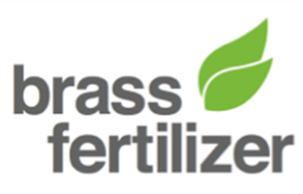
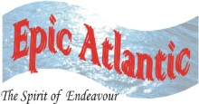
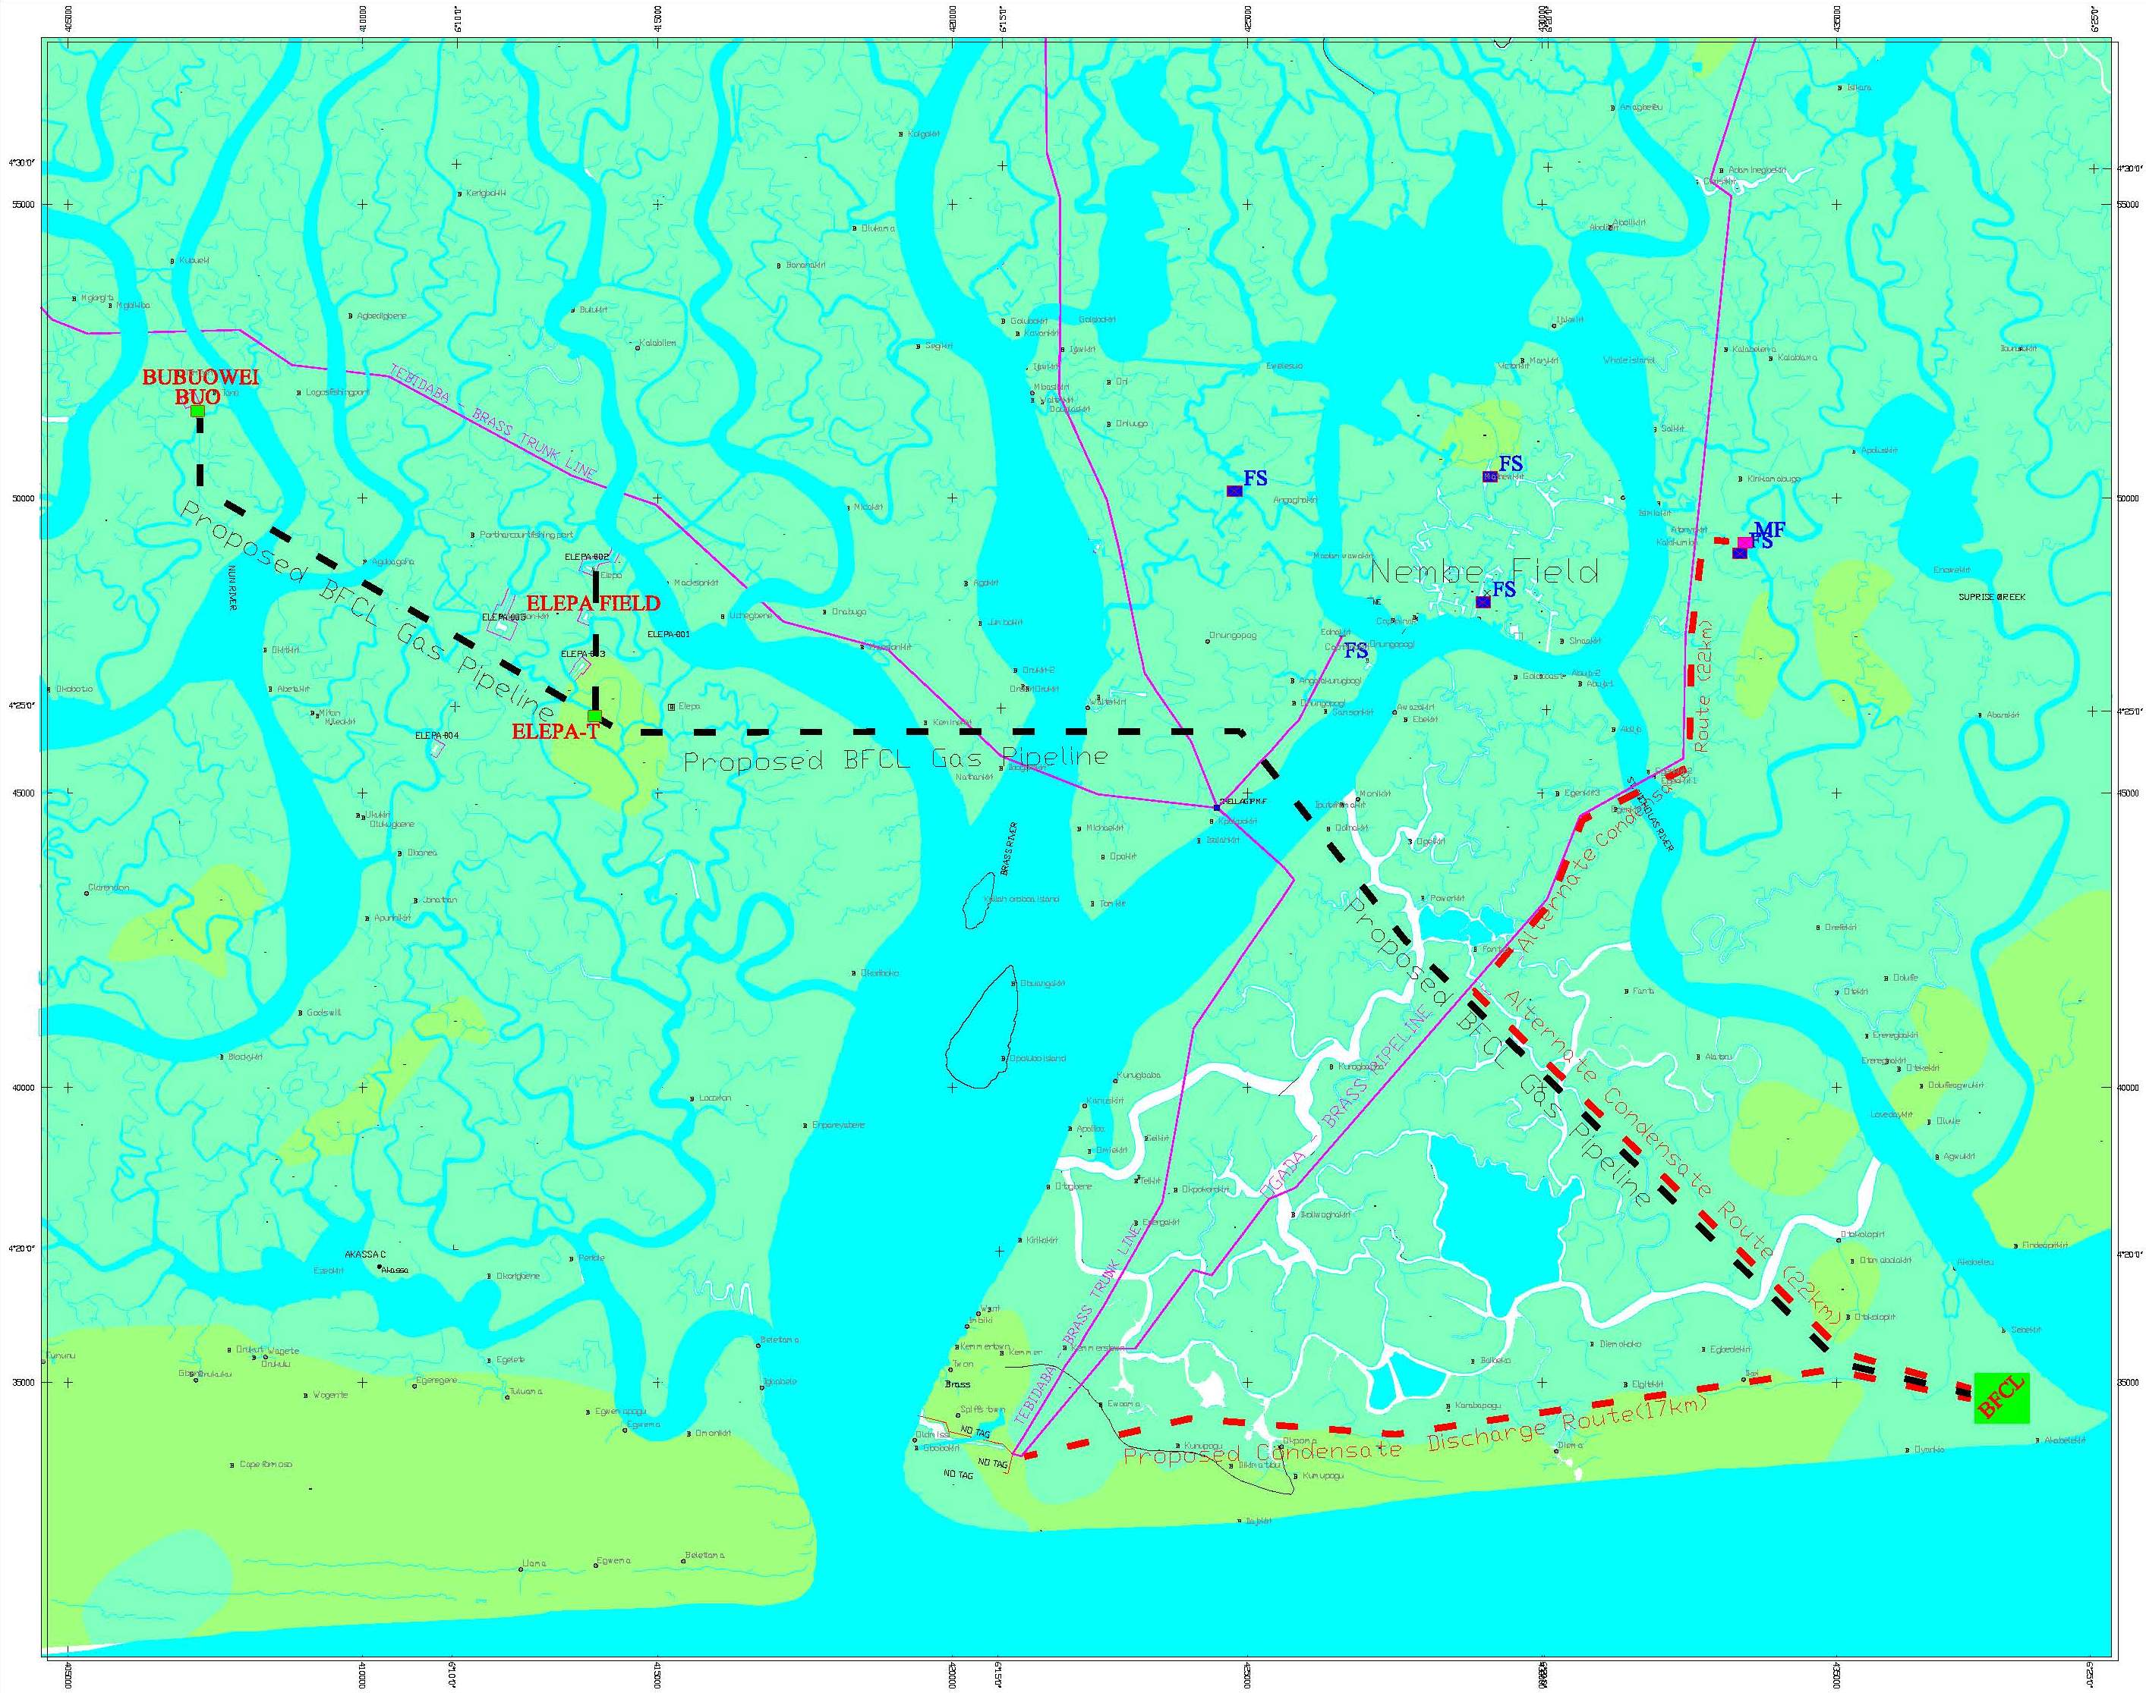
Epic Atlantic Limited
Plot 212 Trans Amadi industrial layout, Port Harcourt
consultants@epicatlantic.com
www.epiatlantic.com
OML 33 GAS SUPPLY TO BRASS FERTILIZER PLANT
PIPELINE ROUTE SELECTION STUDY
INTERIM REPORT
16 December 2013

SUMMARY PAGE
Client: BRASS FERTILIZER COMPANY LTD
Project: OML 33 GAS SUPPLY TO BRASS FERTILIZER PLANT | Title: Pipeline Route Selection Study – Interim Report
Facilities: Gas Gathering Pipelines & Processing Plant | BFCL Project Ref: EA/BFCL/SVY-001

This document serves as a reference to the preliminary works already undertaken in preparation to FP Survey that will be carried out for the subject project. It also demonstrates the state of readiness of the survey team and framework for activities implementation in respect of gathering and processing OML 33 gas for supply as feedstock to Brass Fertiliser Plant.
It highlights the project team’s understanding of the workscope, the high level geomatics & related externality issues, business process, work methods & procedures, quality assurance processes and integration of HSE in and CAS in execution planning, - which are all integral parts of the readiness.
KEY WORDS: brass, design, SURVEY, execution, fertilizer , gas , plant.

REferences |  | Holds
Originator | Document No | Description | Page
EA | TBA

Table of Contents

1. BACKGROUND AND INTRODUCTION 5
1.1. Key Pipeline Route Selection Principles and Influencing Factors 5
2. ENGINEERING DESIGN REQUIREMENTS 7
2.1. Crossing Details of Proposed Main Routes. 8
2.2. Condensate Discharge Crossing Details 8
2.3. Additional 8
3. COMMUNITY LEADERSHIP ENGAGEMENT 10
4. OUTSTANDING FIELD INVESTIGATION 12

BACKGROUND AND INTRODUCTION

Part of the requirements, in fulfilling BFCL’s project objectives is the installation of pipeline to transport the well-products from both BB and Elepa Wellheads to BFCL Base in Akabel. There is therefore, need to identify and select a pipeline routing that will ultimately achieve an economically, technically and environmentally feasible route for construction and operation of the pipeline.
Pipeline route selection, definition and refinement is an iterative processes involving desk-top studies of available information, like topographical and geological maps, aerial photographs and satellite imagery, literatures, environment reports and legacy documentations. Also, there should be consultations with the relevant land owners and stakeholders. The final optimally selected route from the desktop studies will further be investigated on site to ensure that it has accounted for all known key environmental, cultural, geological, archaeological, geotechnical, hydrological, hydrographic, topogragraphic, nature park and biodiversity sensitivities.

Key Pipeline Route Selection Principles and Influencing Factors
The key principles to take into account when performing route selection processes are:-
- Safety of the public and personnel - the route must provide a safe and secured environment for the pipeline during construction and over its operational life and ideally be routed away from populated areas.
- The route should meet the project’s economic objectives, without compromising safety and environment, and minimizing local economy impact on communities that the pipeline passes through, and have the smallest footprint feasible (ideally the shortest distance between pipeline start and end points).
- Land ownership related factors e.g. the number of landowners, anticipated ease and cost to obtain/purchase consents.
- Contents of the pipeline and operating conditions, e.g. consideration of leakage of a high vapour pressure liquids.
- The route must have a minimum negative impact on the environment, nature, biodiversity and minimal land take.
- Terrain and subterranean conditions, including geotechnical, hydrographical, and meteorological conditions should be acceptable. These includes ground stability, including other land uses which may create instability (e.g. sand mining subsidence, land development).
- Cultural heritage sites, should be strictly identified and avoided.
- Existing and future land plan usage. This can be determined by research of public records and consultation with the local land owners and government planning agencies which should identify :-
- Third-party activities
- Agricultural practice
- Facilities and services
- Future development requirements
- Permanent access – the pipeline must ideally be accessible for inspection and maintenance all year round over its operational life
- Security :- The pipeline system should be routed to minimise security concerns, particularly due to trespass and sabotage, during both construction and operation.
- Other unforeseen hazards.

CHRONOLOGY OF ROUTE SELECTION PROCESSES

 | Date | Description | Drw Rev | Remarks
1 | August 2013 | Proposed five routing options R1, R2, R3, R4 and R5. | Rev 0 | By Steve
2 | 29/08/2013 | Optimised the five proposed options to three routes R6, R7 and R8, after applying selection criteria. | Rev 0A | By Paul
3 | 3//09/2013 | Met in Yenegoa with Chief of the three kingdoms spanning the pipeline corridor – BB, Elepa and Odiama Kingdoms to discuss their courtesy call request and seek their advise on the community relations expectations.
4 | 06/09/2013 | Optimised R7 and R8 to R9 and discard R6. The selected route (R9) moved east from BB to Elepa fields, then to south of Nembe field then take southerly turn to Akabel Base. | EA/BF/SVY/DWG-01(R 01) | By Paul
5 | 09/09/2013 | Reviewed and proposed R9 to R10 to turn south to Akabel after second major river crossing , reducing RoW distance from 40 to 37km. | EA/BF/SVY/DWG-01(R 02) | By Paul
6 | 09/09/2013 | Acquired and attached satellite imagery to R10, for further assessment of vegetation and habitation. | EA/BF/SVY/DWG-01(R 03) | By Paul
7 | 17/09/2013 | Finalized and optimised R10 with attached imagery and adjusted all crossings to near perpendicular approach to existing pipeline and river/creek courses. | EA/BF/SVY/DWG-01(R 04) | By Paul
8 | 26/09/2013 | Introduced two proposed condensate discharge routes originating from Akabel: to Nembe Flowstation - 22km with one major river crossing, and,  to Brass Terminal 17km. | EA/BF/SVY/DWG-01(R 05) | By Paul

Crossing Details of Proposed Main Routes.
Description | R-6 | R-7 | R-8 | R-9 | R-10 | R-11
Total length (km. approx) | 42 | 40 | 40 | 40 | 37 | 37
Pipeline Crossings | 3 | 2 | 4 | 4 | 4 | 4
River Crossings (less creek-lets) >200m wide. | 7 | 3 | 7 | 7 | 7 | 7

Condensate Discharge Crossing Details
 | Nembe | Brass
Total Length (km. approx) | 22 | 17
Pipeline Crossings | 0 | 0
River Crossings (less creek-lets) | 1 | 0

Additional Criteria for Route Selection
Below are part of the considerations guiding the route selection and optimization iterated processes from original five routes to one.

- A section of Route-2 runs near parallel to the sea front. This will pose enormous construction and logistics challenges, including the Brass estuarine crossing. Typically, managing estuarine wave turbulence is a major concern during installation works. Besides sea bed dynamics is very rapid in the region.

- Route - 3 has significant major crossing width on the main Brass River channel, but has optimised it to avoid the island within the crossing. In this way, we will do one crossing instead of two. However, this could be substituted with smaller crossings, if we will not be comfortable with such wide crossing, hence R8.

- Routes 1 and 4, traversed Nembe Creek Field. This field is a very busy Shell Field, dotted with existing installations – well head, pipelines, manifolds, etc. Consequently, it is better to stay clear of the field, hence south of it.

- The number of bends was optimised, by eliminating avoidable bends, and staying close to 90 degrees at all river and pipelines crossings.

- For the advantage of land use sharing and impact to vegetation, it may be considered economical and convenient to stay next to Agip's Tebidaba-Brass T/L right of way, but for the obvious shortcomings, which include multiple bends, longer route, potential risks associated with river crossing works next to a life and pressurised line.

- R1, R3, R4 and R5 were therefore optimized to R6, R7 and R8. R6 was later discarded, while R7 and R8 were merged to R9. Later R9 was re-routed to R10 to reduce total length from 40 to 37km. R10 is therefore the best fit desktop selected route with due considerations for all selection criteria, including existing community settlement, pipelines, well heads and widths of river crossings.

COMMUNITY LEADERSHIP ENGAGEMENT

In preparation for physical investigation of the selected route, a site visit was planned. Prior to this, there was a feedback from preliminary consultations that certain conditions will have to be met in terms of courtesy homage payment to the Chiefs of the three Kingdoms. A meeting was therefore schedule for 3rd September 2013 in Yenegoa.
Key objective of the meeting was to formally meet and brief the Paramount Rulers of the communities within the proposed pipeline route, about the project and get their guidance on how to develop an engagement process with the host communities with respect to the pipeline routing and installation processes, starting with the site visit. Below are the key highlights of the meeting:-

- Introduction of the fertilizer/gas project and the intent to lay pipeline from BB through Elepa to transport gas from BB & Elepa wells to the proposed fertilizer site in Odioma Kingdom for processing & feedstock to the fertilizer plant. And that Epic Atlantic has been engaged by BFCL to carry out an assessment of the wellhead areas and pipeline route that will guide installation of the pipeline. Hence this courtesy call to the communities leadership to reach an agreement that will enable Epic Atlantic undertake site visit to the areas for visual assessment and consultation with the land owners, which will later be followed by route survey & land acquisition.
- They noted that Shell was not part of this mission while the wells belong to Shell. They were informed that Shell is one of the stakeholders.
- They stated that they can only lease their land, and not sell.
- They reacted unfavourably to the fact that gas on their land will be transported somewhere else for product transformation, and therefore said that they would like to also see their involvement in terms of shareholding and directorship, - based on the fact that the gas is in their land. They were assured that their message will be taken home.
- They acknowledged our homage as a good starting point and said that we need to reconvene for further discussions and detailing with their wider community where other interest groups (youths, elders, etc) and wider community will be present.

- This visit was considered very good and fundamental, to enable the articulation of a unified community relations approach for the entire communities within the pipeline route.

OUTSTANDING FIELD INVESTIGATION

Field investigation of the selected route from the desktop exercise is the concluding phase of the pipeline route selection process. This will involve site evaluation of the viability of the selected route, including consultations with relevant stake holders.
In addition to the provisions of Section 1.1 above, other critical factors for consideration during the site investigation includes:-
- The river and creek crossing points shall be identified and investigated for construction convenience and other potential hazards and constrains.
- Assessment of the elevation difference at the overland area beyond the rivers/creeks banks, including height of adjacent banks. Abrupt changes of elevation (i.e. steep banks) to be avoided.
- Due consultation shall be held with the local communities to identify if any, some sacred or forbidden bush, biodiversity, legacy, traditional concerns.
Due consultation shall be held with the relevant government agencies for information of planned future land use and any environment requirements.

